Enhancing Personalized Learning of Students through Deep Learning in an Adaptive Learning Environment.

Madushan Pathirana – 2020BA024

Supervisor – Dr. L.N.C De Silva

Table of Content

1 Introduction to E-learning 4

1.1 Introduction to adaptive learning 5

1.1.1 Importance of adaptive learning 5

1.2 Research problem 7

1.3 Research gap 8

1.4 Research question 8

1.5 Research objectives 9

1.6 Research scope 9

2 Literature review 9

2.1 Adoptive learning 9

2.2 Knowledge tracing 10

2.3 Bayesian Knowledge Tracing 11

2.4 Factor analysis models 12

2.5 Deep knowledge tracing and Graph neural network 13

2.5.1 Graph Neural Network 16

2.6 Leaners characteristics 16

2.7 Recommendation system 17

2.7.1 Study material recommendation 18

3 Methodology 19

3.1 Data 19

3.2 Solution design 20

3.2.1 Selection of solution architecture 20

3.2.2 Graph Neural Network (GNN) 21

3.2.3 How GNN works 21

3.3 Graph Neural Model and Validation 23

3.4 Risk 24

4 Reference 25

Table of Figures

Figure 1.1 Adaptive e-learning systems' components (Ennouamani & Mahani, 2018) 6

Figure 2.1 Traditional Knowledge Tracing Methods 11

Figure 2.2 Deep Knowledge Tracing Methods 14

Figure 2.3 structure based knowledge tracing (Tong et al., 2020) 15

Figure 3.1 - Graph Neural Network ( source - Stanford Graph based Machine Learning lecture slides) 22

Figure 3.2 Sample Input Graph 23

Table of Tables

Table 1.1 Types of E learning systems 4

Table 2.1 Bayesian Knowledge Tracing Parameters 12

Table 3.1 Data and Attributes 19

# Introduction to E-learning

Education is one of the fundamental pillars in a society that drives intellectual growth and uplifts social standards. According to United Nations, Universal Declaration of Human Rights, Article 26, ‘Everyone has a right to education’ (UN General Assembly, 1948). At the beginning of the last century, education focused on knowledge and skills without considering the learner's expectations and learners abilities. Hence the ‘one size fits all’ education system faced challenges in catering to individual student requirements. Personalized teaching and learning frameworks immerged to fill this gap with the development of technology. Learning Management Systems (LMS), Adaptive Hypermedia Systems (AHS), and Intelligent Tutoring Systems (ITS) are to name a few systems developed to cater to personalized education. (Katsaris & Vidakis, 2021). Table 1.1 further explain each E-learning system.

Table 1.1 Types of E learning systems

|  |  |
| --- | --- |
| E-learning systems | Characteristics |
| Learning Management Systems | LMS delivers content and help administrative tasks |
| Adaptive Hypermedia Systems | Provide content based on user goal and performance |
| Learning Style based Adaptive Educational Systems | Personalize the learning experience based on learning style (visual, auditory, reading/writing, and kinesthetic) |
| Intelligent Tutoring Systems | Provide immediate and customized instruction/feedback without human intervention using Adaptive Learning |

This study focues in Intelligent Tutoring Systems. According to (Mousavinasab et al., 2021) Intelligent Tutoring Systems (ITSs) consist of four main modules. The first is the expert module, containing domain knowledge and problem-solving techniques. The second is the student diagnosis module, which gathers and updates information about the learner's knowledge, activities, and responses. The third is the instruction module, which detects knowledge deficiencies and employs teaching strategies to address them using adaptive learning technologies. The last module is the user interface, facilitating communication between the user and the system. Incorporating AI techniques, e-learning systems have aimed to enhance adaptive and customized learning. Adaptive feedbakcs what makes intelligent tutoring systems really intelligent. This study further focues on the third instrudction models’ adaptive learning capabilities and how to improve adaptive learning process using deep learning.

## Introduction to adaptive learning

Adaptive learning is a methodology for teaching and learning that strives to personalize lessons, readings, practice activities, and assessments for individual students based on their current skills and performance. Adaptive learning systems use a data-driven approach to adjust the path and pace of learning, enabling the delivery of personalized learning at scale (Ennouamani & Mahani, 2018).

Adaptive learning is a type of scaffolding technique used in educational technology that is tailored to support all stakeholders in an educational institution, including teachers, students, and school administrators. According to (Jan­Martin Lowendahl et al., 2016) adaptive learning adjusts instructional content based on student responses and preferences, relying on learning data and algorithmic pedagogical responses.

### Importance of adaptive learning

There are many benefits of adaptive learning. Adaptive learning saves teachers time and provides data and analytics that help to understand students. For students, it provides a personalized learning experience better suited for their capacity and instant feedback. School administrators can improve student performance, such as pass rate and proficiency. Clark, Kaw and Braga Gomes, (2022) advise adaptive learning give best results when it combined with pre class sessions.

Ennouamani & Mahani, (2018) have summarized adaptive learning systems to 3 models. They are Learning model, Adaptation model and Domain model. The learner model contains the student characteristics such as learning style, reasoning style, interests and student performance history. The domain model contains knowledge of the studying domain, study materials and learning objectives. The adaptation model has adaptation rules that align with the student performance and domain. It asses the student behavior and navigates them to relevant materials in the domain model. A sophisticated adaptive learning system temporally updates its rules and gets feedback from external and internal learning environments. As shown in the Figure 1.1 adaption model feeded by the leaner model and domain model. Then it provide adaptive feedback to the system. System interact with the leaner via graphical user interface. Adaptive model could suggest learner to attempt a easy or hard question, spend more time on basics or take a brake and start learning later.

Adaptive learning positively impacts student performance with empirical evidence, but it depends on the design of the adaptive learning system (Liu et al., 2017). It should be user-centric, and content must properly align with the learning outcomes. An adaptive learning system should be able to provide meaningful feedback and navigate students only to the relevant content.

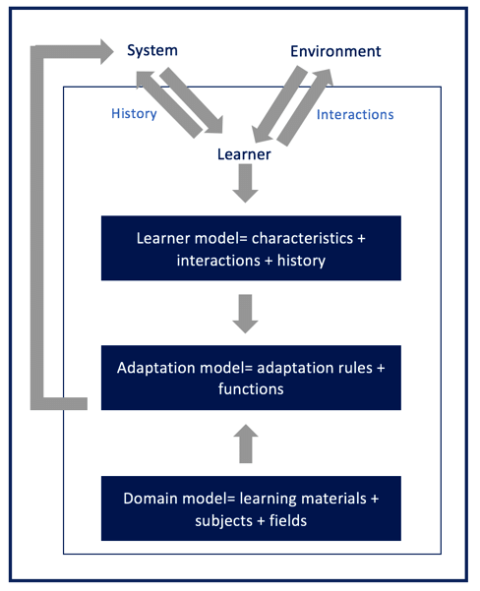

Figure 1.1 Adaptive e-learning systems' components (Ennouamani & Mahani, 2018)

According to (Martin et al., 2020), when educational institutes adopt adaptive learning methods, they face three challenges with respect to technology, instruction, and management. There are technological barriers when schools connect existing learning management systems to adaptive learning methods, real-time data-sharing challenges, and the complexity of adaptive systems. Teachers and instructors not having enough experience can lead to the adaptation of adaptive learning methods. Educational institutions must train and monitor how well they adopt adaptive learning methods. Sometimes educators resist adopting adaptive learning methods due to differences in the curriculums, additional workload, or not having confidence that adaptive learning methods can improve students’ knowledge state. Lack of management support can also lead to adaptive learning method adoption failure. Incompatible organization goals or lack of leadership and insufficient human resources and financial resources can also cause to halt the implementation of adaptive learning systems.

## Research problem

This research studies data sets from a real-world commercial adaptive learning platform. It provides practice questions and assignments targeting science and mathematics school curricula. Practice questions are called Goals on this platform. Each goal consists of multiple answer questions related to learning objectives. If a student gives the correct answer student will be allowed to proceed to the next question. If the student fails the question, he or she will get a new question or be presented with the study materials to refresh their knowledge.

This platform measures the mastery of a student using a modified version of Item Response Theory (IRT) (F. M. Lord, M. R. Novick and Allan Birnbaum, 1968), which is a statistical technique. This method consider only the questions difficulty ,student proficiency and skill discrimination ability of the question. Students ability to answer a question correctly depends on stundets mastery level on the skill represent by the question. But most of the skill have prerequisite skills. Exiting model does not consider the mastery level of prereuqisit skills. Subjected adaptive learning platform has not assessed the impact of study materials. Existing model does not consider the impact of study materials towards students performance. Hence there is requirement to explore novel method to measure students mastery level considering prequisits skill and study materials impact.

Current system provide lots of value informations to teachers such as mastery level achived by the students and the degree of effort each student have to put to reach the mastery level. This helps teachers to undestand individual students learning rate. If students are clustered based on the learning rate, teachers can analyze the class separate clusters and identify common poor skills among student clusters. This will help teachers rather than spend time on individual stundets weak areas, spend time one multiple students who has common weak skills.

## Research gap

In literature, knowledge tracing is widely researched under many branches. In the early stages, Bayesian knowledge tracing (KT) was the most popular method for knowledge tracing method. Later IRT was introduced, and recently with the boom of deep learning, deep knowledge tracing was introduced. DKT outperformed all previous techniques, and there are many applications under all the branches. They predict students' ability to answer a question correctly, recommend learning materials or questions, assess the quality of the education, and many more.

When our data set is compared to the literature, our data set also has the sequence of questions under different learning objectives and the correctness of the answers like in other studies. One specialty in our data set is, middle of the question sequence, students referred to learning materials if they have poorly performed for the related learning objective , and attempted again. In the previous research work study materials are not included in the research problem. This can be used to measure the quality of the learning materials and how it impacts each student. Additionally, we attempt to incorporate question difficulty into the problem formulation.

In terms of learner characteristics, this research analyzes the possibility of clustering the students based on their prior knowledge and performance. The proposed study will also analyze the impact of study or the instruction materials provided to shape the leaners characteristics.

## Research question

1. What factors influence students’ personalized learning experience within an adaptive learning environment?

2. How does choice of learning materials affect students' personalized learning experience in an adaptive learning environment?

## Research objectives

1. Identify the factors that influence personalized learning experiences in an adaptive learning environment.
2. Evaluate the effectiveness of study material utilization towards improving student mastery level.
3. Explore the potential of deep learning techniques in enhancing personalized learning experiences for students.

in the initial proposal there were 4 objectives. 4th objective was to explore the use of machine learning to recommend learning material. Recommendation system can not be validate without implementing the system in the real world. Due to constraints in implementing the system in the real world 4th objective is omitted. In other hand , 3rd objective is a prerequisite to the proposed 4th objective. Due to complexity of the 3rd objective and time limitation, we limited the research to the first 3 objectives.

## Research scope

The scope of the study is to analyzes a real-world dataset from an adaptive learning platform. It focuses on student coursework performance, assignments, learning objectives and knowledge graphs. The scope is to cluster students based on performance and predict the mastery level of students.

# Literature review

## Adoptive learning

“ Adaptive learning as an educational technology is a kind of scaffolding technique customized to help all stakeholders in an educational institution, teachers, students and school administrators” (Castañeda & Selwyn, 2018)

According to Ennouamani and Mahani, (2018) there are 3 main adaptive learning approaches. They are ;

* Macro-Adaptive Approach - This approach allows the user to move between courses at an adapted rate. It also considers the learning objectives and cognitive and intellectual characteristics. The instructor has to initiate the narrative.
* Aptitude-Treatment Interaction (ATI) Approach - This approach identifies the learner's aptitude and then alters the course of action to improve the learner's abilities. These systems can be used to develop Intelligent Tutoring Systems by generating learning materials suited to individual learner's capabilities.
* Micro-Adaptive Approach - This approach analyzes the learner and understands the learner's requirement or knowledge gap. It is a more dynamic system that considers real-time characteristics of the learners.

This study focuses on building Aptitude-Treatment Interaction (ATI) Approach using deep learning. The ATI approach emphasizes the user's control over the learning process. Studies have shown that the success of self-control in learning depends on the learner's abilities, suggesting that it may be beneficial to limit control for students with low prior knowledge and enhance it for high-performing students. It introduces three levels of control: complete independence, partial control within task scenarios, and fixed tasks with controlled pace.

Intelligent Tutoring Systems (ITS) utilize the ATI approach to detect users' skills. ITS implementation is based on adaptive e-learning system architecture, comprising the learner model and domain model. An adaptation model is used to generate and present adapted materials to each learner. This approach is also applied in adaptive hypermedia systems, where the goal is to design learning solutions that integrate hypermedia content in ITS to tailor it to individual learner profiles

## Knowledge tracing

Human teachers can measure students' level of understanding and take necessary actions to fill the gaps. In the computer base teaching era, machines must learn the students' degree of understanding and take action to fill the knowledge gap. Abdelrahman, Wang, and Nunes (2023) Recognize this process as **Knowledge Tracing (KT)** . These KTs are widely used in Massive Open Online Courses (MOOCs), Intelligent Tutoring Systems (ITS), educational games, and adaptive learning platforms. However, capturing student knowledge level is not easy because questions can require multiple skills, dependency among skills, and forgetting or decaying knowledge over time. Since John R. Anderson introduced knowledge tracing in 1986, researchers have attempted to develop many machine-learning models to solve KT.

Figure 2.1 Traditional Knowledge Tracing Methods

## Bayesian Knowledge Tracing

First generation of Traditional KT models were based on Bayesian Knowledge Tracing (BKT). Bayesian Knowledge Tracing (BKT) is inspired by mastery learning, which assumes that all students can achieve mastery of a skill under two conditions:

* Knowledge is organized as a hierarchy of skills, and
* Learning experiences are structured to ensure mastery of lower-level skills before moving to higher-level ones.

BKT models typically employ probabilistic graphical models like Hidden Markov Model and Bayesian Belief Network to track students' evolving knowledge states as they practice skills.

First BKT model was developed by Corbett and Anderson in 1994 (Albert T. Corbertt & John R Anderson, 1994). It considered two statues of student learned or unlearned. This model assumed that students do not forget what they mastered. . But it considers the probability that students may guess the answer p(G) or mistakenly select the wrong answer (slip) p(S).

This model consider as the standard BKT model. It has four parameters.

Table 2.1 Bayesian Knowledge Tracing Parameters

|  |  |
| --- | --- |
| Parameter | Description |
| p(L0) | Probability of skill mastery by a student before learning |
| p(T) | Probability of transition from an unlearned state to a learned state |
| p(S) | Probability of slipping by a student in a learned state |
| p(G) | Probability of guessing correctly by a student in an unlearned state |

At each time step n ≥ 1, the model estimates the probability p(Ln ) of skill mastery by a student by

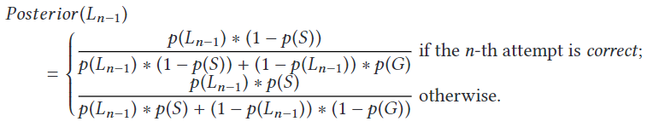

## Factor analysis models

Factor analysis models are the second branch of traditional knowledge tracing methods. It plays a vital role in measuring assessments. Factor analysis models are based on Item Response Theory (IRT). This study use a data set from a commercial adaptive learning system that measures students proficiency using IRT. Our data set assed using a modified version of IRT which has a memory of previous performance and it helps to reach the mastery level based on the students adaptive rate.

Item Response Theory is a psychometrics method, which means it is statistical framework to analyze and understand the properties of individual test items/questions and the performance of test-takers on each item. It is introduced by F. M. Lord et al., 1968. IRT performance as a logistic function.

According to IRT every question has a degree of difficulty and student has a level of ability. Below equation is the basic form of ITR. $p_{ij}$ is the probability of student *i* answering correctly to the question *j*. ai is the ability of student *i* and bj is the difficulty of the question *j.*

$$p_{ij}=\frac{e^{a_{i}-b_{j}}}{{1+e}^{a_{i}-b_{j}}}$$

Assumptions in IRT;

* Probability of student correctly answering a question model as an item response function
* Item response function monotonically increase with respect to the ability of the student
* Questions are conditionally independent.

## Deep knowledge tracing and Graph neural network

Piech et al., (2015) Lead the **Deep Knowledge Tracing** **(DKT)** introducing deep knowledge tracing **.** DKT mainly uses deep learning to predict students' ability to answer a question correctly. DKT models have outperformed traditional knowledge tracing models. From the machine learning perspective knowledge tracing is sequence modeling task. It try to predict the next state of the sequence (students ability to answer the next question given the previous questions and performance). Hence deep learning models have use Recurrent Neural Networks (RNN) or Long Short Memory (LSTM) to model the sequence. There are many branches under DKT.

Figure 2.2 Deep Knowledge Tracing Methods

Despite its encouraging performance DKT models had some drawbacks. They cannot predict the outcome of questions related to multiple skills. Also, it can not model the connection between multiple skills. It also assumes that all the questions are related to each other with the same probability which is not likely to happen all the time. Researchers try to overcome these limitations using Extended-deep knowledge tracing, which introduces by (Piech et al., 2015). They added additional student features such as previous knowledge, question answering rates and time spent on learning and practice; and, exercise features, such as textual information, question difficulty, skill hierarchies and skill dependencies.

But these limitations successfully overcome by Graph based Knowledge Tracing models. They can integrate the relationship between knowledge concepts and questions. Nakagawa et al., 2019 introduced Graph based knowledge tracing. They present knowledge concepts by nodes and relationships between them using edges. They formulated the problems as time series classification problem at node level.

According to (Abdelrahman et al., 2023) there are three main graph-based KT models. They are

* graph-based knowledge tracing
* graph-based interaction knowledge tracing
* structure-based knowledge tracing (SBKT)

This research leans toward structure-based knowledge tracing as we use knowledge graphs representing relationships between knowledge concepts (KC/learning objective (LO) as per our data set).

Tong et al.,(2020) introduced the structure-based knowledge tracing method. They have tried to solve two main challenges in this paper. They are the temporal impact of exercise sequence and the spatial impact of the knowledge structure or knowledge graph. In order to solve these challenges, they have introduced structure-based knowledge tracing(SBKT). SBKT can simultaneously model the temporal and spatial impacts.

Figure 2.3 structure based knowledge tracing (Tong et al., 2020)

Figure 2.3 depict sequence of exercises related to one knowledge structure. Under this structurer there are connected concepts. They are either prerequisites or similar concepts. As the student proceed with the question students knowledge statues of each concept change. It is shown in the radar map in the top. Changes in radar map shows the temporal impact of the students’ knowledge statues and knowledge structures shows how responses impact the learning concept and related(influenced) concepts, which is the spatial impact.

### Graph Neural Network

The rapid development of internet technology and web applications has led to a vast amount of data being generated on the internet, which can be used to create valuable knowledge. Such knowledge lead to create knowledge graphs. Graph Neural Network (GNN) created to learn from such knowledge graphs and predict the unknown. GNN are a class of deep learning methods designed to perform inference on data described by graphs. They are neural networks that can be directly applied to graphs, allowing for node-level, edge-level, and graph-level prediction tasks (Ye et al., 2022).

The message parsing process is what allows GNNs to learn from the structure of the graph. By sending messages to each other, the nodes in the graph are able to share information about their local neighborhoods. This information can then be used to update the nodes' states, which in turn can be used to make predictions about the graph. There are a variety of different message parsing functions that can be used in GNNs. The choice of message parsing function depends on the specific task that the GNN is being used for. For example, if the GNN is being used to predict the relationship between two entities, then the message parsing function might be designed to extract features from the entities and their relationships (Serra & Niepert, 2023).

## Leaners characteristics

Hemmler and Ifenthaler, (2022) have identified internal and external indicators of the learning context for supporting adaptive learning. Based on the authors internal dimensions, Past performance is a one dimension that support toward adaptive learning. It can be measure through previous grades, rank, previous experience with the course content, prior credits and course repetition. All these indicators are included in our data set. Additionally under skills and abilities dimension, prior knowledge indicator also captured in our data set. In contrary there are many other dimensions such as demographics, learning approach, emotions, perception towards teacher/course and etc. Hence our study limited only to student performance and skill/abilities dimension when analyzing learners characteristics in an adaptive learning environment.

Afini Normadhi et al.,( 2019) summarize learners personal traits in 3 main domains and the relevant sub domains.

* Cognition – learning style /cognitive style/ prior knowledge/ personality type/thinking process/working memory capacity.
* Affective – emotions/ mental state/ engagement
* Behavior/psychomotor – cognitive abilities/ performance

Our study based on performance under Behavior/psychomotor and prior knowledge under cognition.

Authors conclude most of the adaptive learning environments build on personal traits under cognitive learning domain. Most frequently used personal trait identification method is computer based detection using machine learning (majority ) , without machine learning or hybrid approach. Authors mentioned most of the research work suffer with small sample size which address in our study. And our work intend to use knowledge graph based approach which was not used mention in (Afini Normadhi et al., 2019) literature review from 2007-2017.

Hsu,( 2012) developed Learning Effort Curve Mode using dynamic real-time based learning effort quantification technique ( related work from the same author). This author has used learning style, learning efficiency and self-efficacy as learner characteristics. In the evaluation author has grouped 125 students in to 16 groups and measured Learning Effort Curve Mode. Author has found, despite the learning style or characteristics, descending learning effort leads to ascending learning performance for high learning efficacy groups . Similarly ascending learning effort leads descending learning performance low learning efficacy groups.

## Recommendation system

Rule-based filtering systems rely on manually or automatically generated decision rules that are used to recommend items to users. Content-based filtering systems recommend items that are considered sufficiently similar to the content descriptions in the user profile. Collaborative filtering systems, also referred to as social filtering, match the rating of a current user for items with those of similar users in order to produce recommendations for items not yet rated or seen (Duval et al., 2007)

### Study material recommendation

Duval, Klamma and Wolpers, (2007) developed an advance recommendation engine to recommend links to students in an E-learning platform. Regular recommendation engines, consider all the users logs at once to recommend links using sequential pattern mining algorithms. These authors have clustered users using k-means clustering algorithm (2-5 clusters) considering number of pages visited and the average knowledge obtained from these pages. Then they have applied AprioriAll, GSP and PrefixSpan sequential pattern mining algorithms for each cluster to generate recommendation rules. This new approach have generated similar or more rules for the same support and with high confidence compared to using all user data at once. As per the conclusions, GSP and PrefixSpan algorithms have shown better slightly better results when there are 2 or 3 clusters. In our approach we can generate 2 or 3 clusters to identify similar students. These authors haven’t consider the learning objectives but students navigation through the web site. Our work can also consider the number of questions and instruction materials referred and the student progress in the learn path ( similar to average knowledge ) as features for the clustering algorithm. Our data set do not contain students activity log but students performance in relation to learning objectives. And the due graph nature of our data set make it more complex to analyze.

Borges and Stiubiener, (2014) developed a recommendation system to suggest learning materials to students based on the learning style of the students and the relevant learning objectives. Authors have clustered the students based on their learning style, they have identified 6 learning styles based on input , perception and process (Richard Felder, 2002), and how different learning materials associated with the learning style. Then utility function developed to measure the distance between learning objectives and learning style(LS) using Manhattan distance. Utility function range from 0 to 6, 0 indicate no difference between LO and LS. 6 indicate LO and LS is totally different from each other. Based on utility function results they and LS they suggest the learning materials. They have tested this system with 28 students and 362 recommendations, 89% of the students are satisfied with the results. In their research , they have not considered the students performance and applied for a small student group. Contrary in our study we consider students performance history and student performance after referring the learning materials. Our study based on large pool of students. Additionally we map LOs with knowledge graphs and how student performance related to each LO.

# Methodology

## Data

This research uses a real-world data set from an International E-learning (courseware) platform that uses state of the art adaptive learning technology. This platform provides educational content targeting schools for Mathematics, Economy, Chemistry, Biology, Physics and Psychology. Based on the research question, identified data was already collected with the organization’s approval.

Subjected Adaptive Learning Platform (ADP) measures the learners' progress level ranging from 0 to 100. Teachers can assign assignments to the student related to a specific Learning Objective(LO). A student has to reach 100 progress to complete the assignment, then the student has achieved the ‘Mastery’ to that LO. Each LO has minimum 4 question, progress of a student for a given LO is

Progress = proficiency score x fraction of the minimum questions learner have tried

If student fail master a LO, student get to do more practice questions. If the student need further support, he or she get more instructions and direct back to the prerequisite LOs.

All the learning objectives, concepts, questions, and course materials are associated to knowledge graphs. These knowledge graphs and progress levels drive the students journey to master a given learning objective. But other characteristics of the student joinery are not considered. Such as time spent on a question, time spent on instructions, quality of the instruction materials, etc.

Table 3.1 Data and Attributes

|  |  |  |
| --- | --- | --- |
| Data | Number of data points | Attributes |
| Student coursework performance | 3.3 million | * Learning objectives * coursework id * user id * progress * question id * correctness of the answer * time spent to answer * time spent for the question instruction * study material id referred |
| Student assignment | 140,000 | * Learning objectives * test id * user id * question id * correctness of the answer |
| Learning objective map (knowledge graph) | 1145 | * Source LO Id (prerequisite LO ID) * Destination LO Id * Source LO Title (prerequisite LO Name) * Destination LO Title |

## Solution design

### Selection of solution architecture

According to the literature authors have used different methods to solve knowledge tracing. There mainly two methods. First method is Traditional knowledge tracing which has two branches. They are;

1. Bayesian knowledge tracing
2. Factor analysis models

Second method is Deep knowledge tracing. This is the latest knowledge tracing methodology, and it has outperformed Traditional knowledge tracing methods. Our dataset has already tested with modified item response theory which is one of the models under Factor analysis models. Hence Traditional knowledge tracing methods will not be used for this research. Instead, Deep knowledge tracing methods will be employed expecting better performance.

Under Deep knowledge tracing there are multiple models. All these models use Deep Neural Networks with different input types and different neural network architecture. Subjected data set has heterogenous data types and relationship between these data better explained by Graphs/Networks. Hence this study will use Graph based knowledge tracing methodology to predict students’ knowledge level. There are multiple graph based knowledge tracing methods in literature and this study will compare and contrast different model when building the model.

### Graph Neural Network (GNN)

The evolution of Graph Neural Networks (GNNs) has given rise to numerous applications across diverse domains, including but not limited to Natural Language Processing (NLP) Computer Vision (CV), and Recommendation Systems . GNNs, with their capacity to capture high-order information, have paved the way for substantial advancements in these fields. In our research, we harness the power of Graph Convolutional Neural (GCN) within our Graph-based Interaction Knowledge Tracing (GIKT) model. By employing GCN, we aim to extract meaningful relations between skills and questions, effectively translating them into rich and informative representations. As far as our knowledge extends.

### How GNN works

Graph Neural Networks (GNNs) are a type of deep learning model designed to work with graph-structured data, where data is organized as nodes connected by edges (like a social network, a road map, or a recommendation system). GNNs aim to understand and process this data effectively.

Each node in the graph starts with an initial representation, typically as a vector of numbers. These initial representations capture the characteristics of each node.

GNNs operate through a process of message passing. At each step, each node sends messages to its neighboring nodes. These messages typically contain information about the node itself and its immediate neighbors. The idea is that nodes can exchange information and learn from each other.

After receiving messages from their neighbors, nodes aggregate this information to update their own representation. This aggregation process combines the information from the node itself with that of its neighbors. This is done by Neural Networks. In the below Figure 3.1 gray boxes show the neural networks.

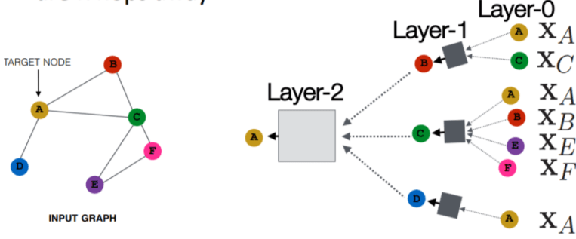

Figure 3.1 - Graph Neural Network ( source - Stanford Graph based Machine Learning lecture slides)

For example, (XA) is a feature vector of node A. The inputs are those feature vectors, and the box will take the two feature vectors (XA and Xc), aggregate them, and then pass on to the next layer.



Equation 3.1 - feature vector

Notice that, for example, the input at node C are the features of node C, but the representation of node C in layer 1 will be a hidden, latent representation of the node, and in layer 2 it’ll be another latent representation. At each kth layer, $h_{v}^{k}$ feature vector produced by the Equation 3.2. It average the previous layer by the number of nodes in the current layer and add bias to previous layer, then perform a nonlinear activation denoted by σ. Wk (weight matrix) and Bk (bias matrix) are trainable parameters.

Equation 3.2 - Neighborhood aggregation

## Graph Neural Model and Validation

In order to measure the student’s mastery level, this study aim to predict the student’s probability to the give the correct answer given the previous interactions, previous answers and current question difficulty. Model is trained to predict whether student will provide the correct answer or a wrong answer. Hence it is a classification problem.

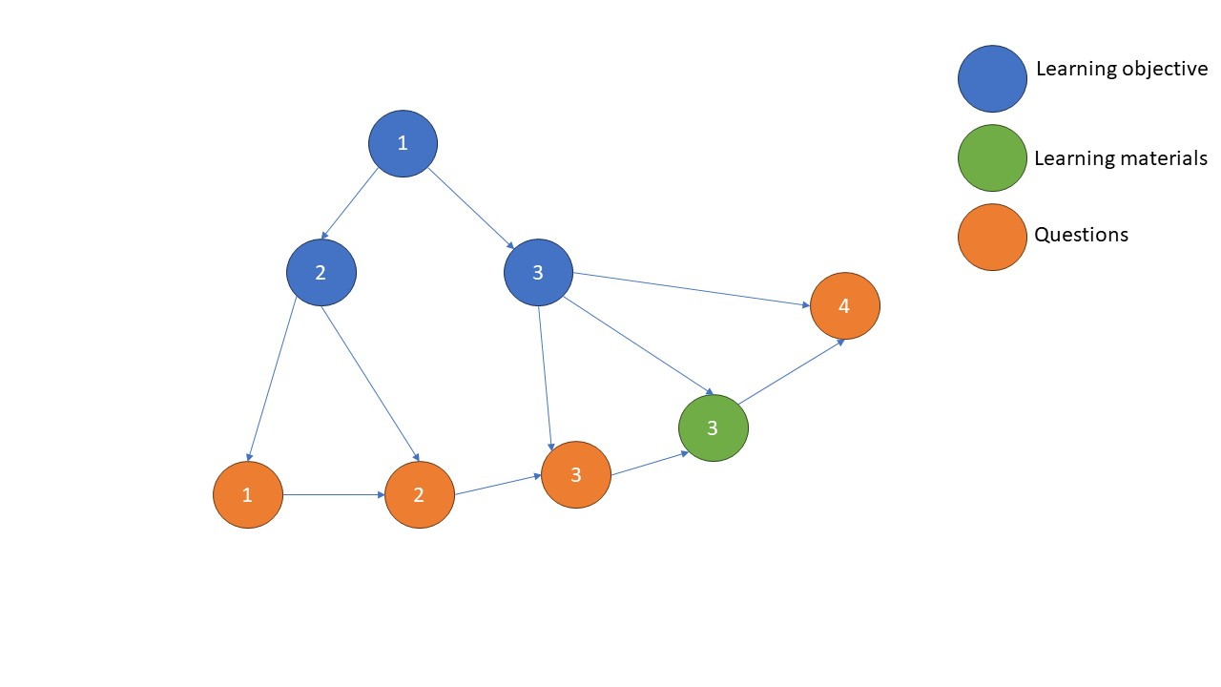

Figure 3.2 Sample Input Graph

Each input is a graph of learning objectives, questions, and answers of a single student of a given assignment. Single batch of inputs are generated from a single assignment attempted by multiple students. Each graph is a directed graph with nodes representing learning objectives, questions and learning materials. Each node has a feature vector. It can be difficulty of the question or time spend on the learning material. Optimal feature vectors can be determined based on the model performance and literature. Target variable is answer which is separate vector at question nodes. Therefore this is node level classification problem.

Learning objectives have edges between their prerequisites learning objectives and following learning objectives. Edges between learning objectives starts from prerequisite learning objectives. edges between learning objective and questions or learning objective and learning materials always start from a learning objective.

Questions and learning materials linked based on the order of interactions. That means edge between question nodes and learning materials direction depend on sequence of the question or learning material interacted by the student. That means if student attempts question 2 first and then question 3 next, edge between question 2 and 3 start from the question 2. If a student refers learning material 1 and attempt question 1 next, then edge starts from the learning material. These directions are important because it determines the message parsing direction the GNN.

Hence this is a node level classification problem we can use precision, recall, f-score, accuracy, sensitivity, and specificity to validate the model. It is important to identify poorly performing students correctly (students tend to give wrong answers) and well performing students. Hence, we will use accuracy or f-score to compare different models. 80% of the data (80% of the nodes in each graph) will be select for training and 20% of the nodes will be selected for testing. We will develop multiple GNN models with increasing complexity in the architecture and adding recurrent layers to model and compare each model performance to select the best model.

In the existing body of literature, the prevailing approach has been to employ Traditional knowledge tracing methods as the foundational models for benchmarking purposes. In our research endeavor, we intend to adopt a similar strategy, although we acknowledge that the inherent intricacies of our dataset may pose challenges to the efficacy of this conventional approach. Consequently, should the traditional methods prove inadequate, we will pivot towards utilizing the simplest Graph Neural Network (GNN) model as our baseline. Additionally, our research aims to provide a comparative analysis of the proficiency levels exhibited by students in the original dataset in contrast to those observed within our dataset.

## Risk

Currently notified risk is not having enough hardware capacity to perform computations. This risk could be overcome by batch wise processing.

# Reference

Abdelrahman, G., Wang, Q., & Nunes, B. (2023). Knowledge Tracing: A Survey. *ACM Computing Surveys*, *55*(11), 1–37. https://doi.org/10.1145/3569576

Afini Normadhi, N. B., Shuib, L., Md Nasir, H. N., Bimba, A., Idris, N., & Balakrishnan, V. (2019). Identification of personal traits in adaptive learning environment: Systematic literature review. *Computers and Education*, *130*, 168–190. https://doi.org/10.1016/j.compedu.2018.11.005

Albert T. Corbertt, & John R Anderson. (1994). Knowledge Tracing : Modeling the acquisition of procedural knowledge. *User Modeling and User-Adapted Interaction*.

Borges, G., & Stiubiener, I. (2014). Recommending Learning Objects Based on Utility and Learning Style. *Opening IEEE-Innovations and Internationalization in Engineering Education* .

Castañeda, L., & Selwyn, N. (2018). More than tools? Making sense of the ongoing digitizations of higher education. In *International Journal of Educational Technology in Higher Education* (Vol. 15, Issue 1). Springer Netherlands. https://doi.org/10.1186/s41239-018-0109-y

Clark, R. M., Kaw, A. K., & Braga Gomes, R. (2022). Adaptive learning: Helpful to the flipped classroom in the online environment of COVID? *Computer Applications in Engineering Education*, *30*(2), 517–531. https://doi.org/10.1002/cae.22470

Duval, E., Klamma, R., & Wolpers, M. (2007). LNCS 4753 - Personalized Links Recommendation Based on Data Mining in Adaptive Educational Hypermedia Systems. In *LNCS* (Vol. 4753).

Ennouamani, S., & Mahani, Z. (2018). An overview of adaptive e-learning systems. *2017 IEEE 8th International Conference on Intelligent Computing and Information Systems, ICICIS 2017*, *2018-January*, 342–347. https://doi.org/10.1109/INTELCIS.2017.8260060

F. M. Lord, M. R. Novick, & Allan Birnbaum. (1968). *SOME LATENT TRAIT MODELS*.

Hemmler, Y. M., & Ifenthaler, D. (2022). Indicators of the Learning Context for Supporting Personalized and Adaptive Learning Environments. *Proceedings - 2022 International Conference on Advanced Learning Technologies, ICALT 2022*, 61–65. https://doi.org/10.1109/ICALT55010.2022.00026

Hsu, P.-S. (2012). LEARNER CHARACTERISTIC BASED LEARNING EFFORT CURVE MODE: THE CORE MECHANISM ON DEVELOPING PERSONALIZED ADAPTIVE E-LEARNING PLATFORM. In *TOJET: The Turkish Online Journal of Educational Technology* (Vol. 11, Issue 4).

Jan­Martin Lowendahl, Terri­Lynn B, Thayer, & Glenda Morgan. (2016). *Top 10 Strategic Technologies ImpactingHigher Education in 2016*. http://www.gartner.com/analyst/26873

Katsaris, I., & Vidakis, N. (2021). Adaptive e-learning systems through learning styles: A review of the literature. *Advances in Mobile Learning Educational Research*, *1*(2), 124–145. https://doi.org/10.25082/AMLER.2021.02.007

Liu, M., McKelroy, E., Corliss, S. B., & Carrigan, J. (2017). Investigating the effect of an adaptive learning intervention on students’ learning. *Educational Technology Research and Development*, *65*(6), 1605–1625. https://doi.org/10.1007/s11423-017-9542-1

Martin, F., Chen, Y., Moore, R. L., & Westine, C. D. (2020). Systematic review of adaptive learning research designs, context, strategies, and technologies from 2009 to 2018. *Educational Technology Research and Development*, *68*(4), 1903–1929. https://doi.org/10.1007/s11423-020-09793-2

Mousavinasab, E., Zarifsanaiey, N., R. Niakan Kalhori, S., Rakhshan, M., Keikha, L., & Ghazi Saeedi, M. (2021). Intelligent tutoring systems: a systematic review of characteristics, applications, and evaluation methods. In *Interactive Learning Environments* (Vol. 29, Issue 1, pp. 142–163). Routledge. https://doi.org/10.1080/10494820.2018.1558257

Nakagawa, H., Iwasawa, Y., & Matsuo, Y. (2019). *GRAPH-BASED KNOWLEDGE TRACING: MODELING STUDENT PROFICIENCY USING GRAPH NEURAL NET-WORK*.

Piech, C., Bassen, J., Huang, J., Ganguli, S., Sahami, M., Guibas, L., Sohl-Dickstein, J., University, S., & Academy, K. (2015). *Deep Knowledge Tracing*.

Richard Felder, by M. (2002). *LEARNING AND TEACHING STYLES IN ENGINEERING EDUCATION*. http://www.ncsu.edu/felder-public/ILSpage.html

Serra, G., & Niepert, M. (2023). *L2XGNN: Learning to Explain Graph Neural Networks*.

Tong, S., Liu, Q., Huang, W., Huang, Z., Chen, E., Liu, C., Ma, H., & Wang, S. (2020). Structure-based knowledge tracing: An influence propagation view. *Proceedings - IEEE International Conference on Data Mining, ICDM*, *2020-November*, 541–550. https://doi.org/10.1109/ICDM50108.2020.00063

Ye, Z., Kumar, Y. J., Sing, G. O., Song, F., & Wang, J. (2022). A Comprehensive Survey of Graph Neural Networks for Knowledge Graphs. *IEEE Access*, *10*, 75729–75741. https://doi.org/10.1109/ACCESS.2022.3191784